SPRINT-2

Date | 02 NOVEMBER 2022
TEAM ID | PNT2022TMID04063
Project Name | IoT Based smart crop Protection system for agriculture
Maximum mark | 20 marks

STEP1: Setup Node-Red

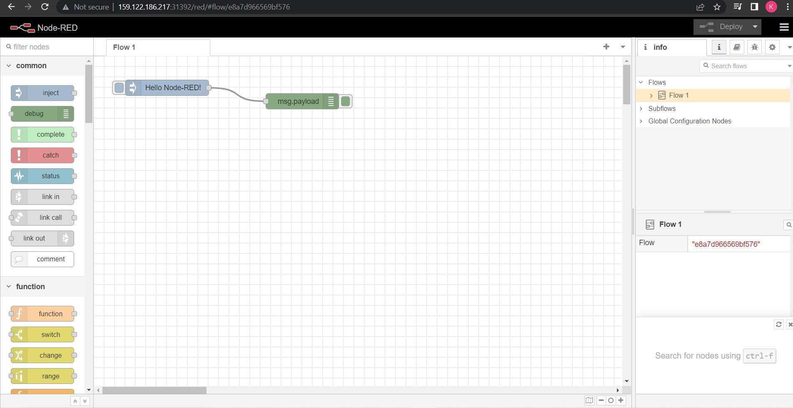
STEP 2: Connect IBM IOT in and Debug 1 and Deploy.
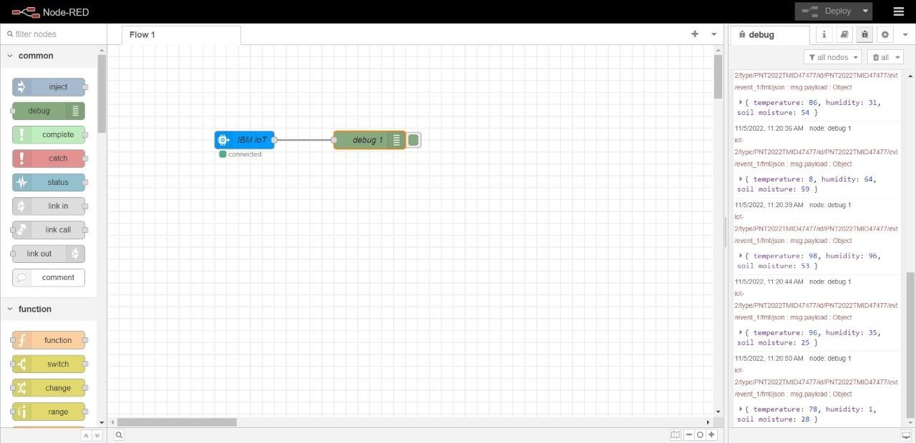

STEP 3: Edit gauge node (Here the gauge nodes are named as Temperature, Humidity and Soil moisture).
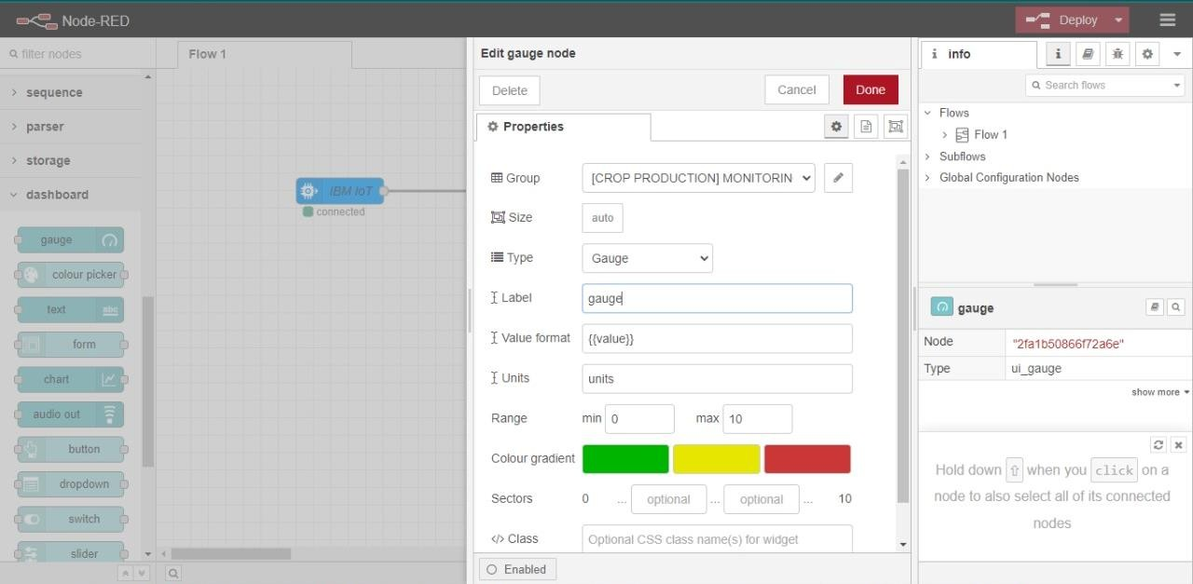

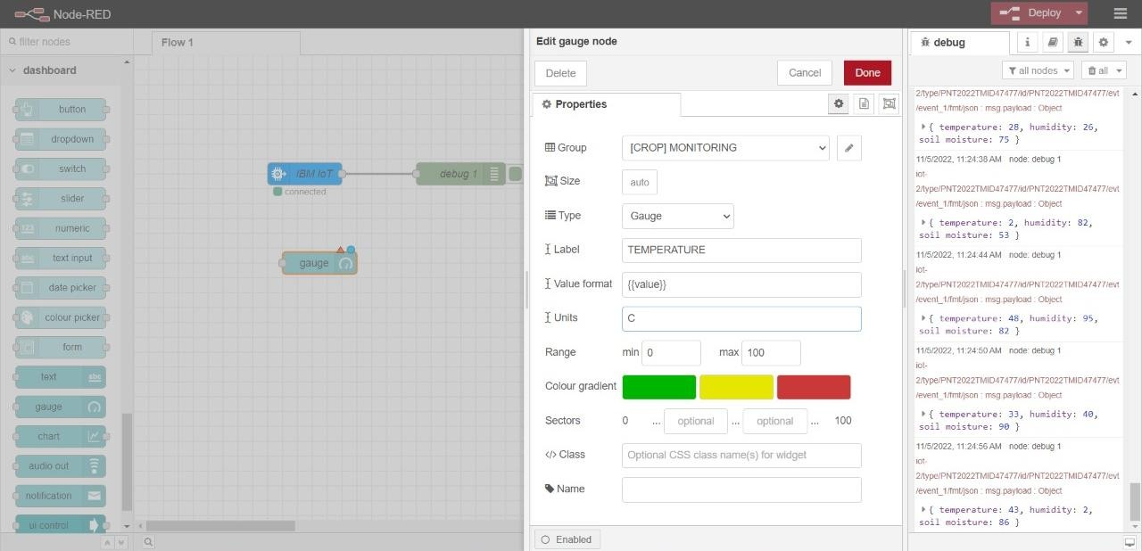

STEP 4 : PYTHON CODE
import time
import sys
import ibmiotf.application # to install pip install ibmiotf
import ibmiotf.device

#Provide your IBM Watson Device Credentials
organization = "hrodmj" #replace the ORG ID
deviceType = "NODEMCU1"#replace the Device type wi
deviceId = "12345"#replace Device ID
authMethod = "token"
authToken = "kp1234" #Replace the authtoken

def myCommandCallback(cmd): # function for Callback
print("Command received: %s" % cmd.data)
if cmd.data['command']=='motoron':
print("Motor On IS RECEIVED")

elif cmd.data['command']=='motoroff':
print("Motor Off IS RECEIVED")

if cmd.command == "setInterval":

if 'interval' not in cmd.data:
print("Error - command is missing required information: 'interval'")
else:
interval = cmd.data['interval']
elif cmd.command == "print":
if 'message' not in cmd.data:
print("Error - command is missing required information: 'message'")
else:
output=cmd.data['message']
print(output)

try:
deviceOptions = {"org": organization, "type": deviceType, "id": deviceId, "auth-method": authMethod, "auth-token": authToken}
deviceCli = ibmiotf.device.Client(deviceOptions)
#..............................................

except Exception as e:
print("Caught exception connecting device: %s" % str(e))
sys.exit()

# Connect and send a datapoint "hello" with value "world" into the cloud as an event of type "greeting" 10 times
deviceCli.connect()

while True:

deviceCli.commandCallback = myCommandCallback

# Disconnect the device and application from the cloud
deviceCli.disconnect()

